
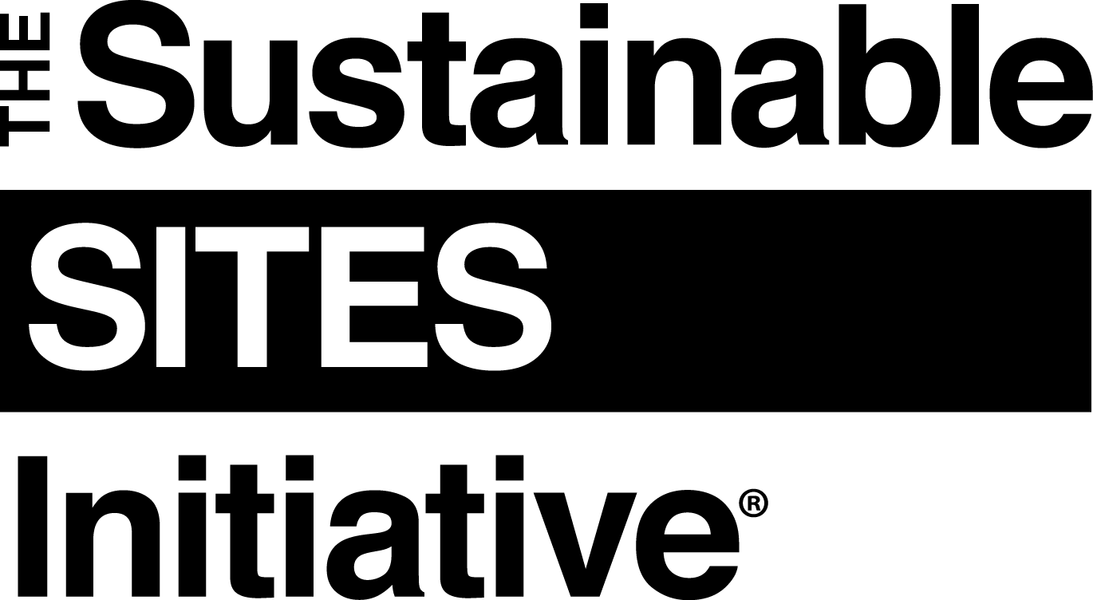

[DATE]

[COMPANY NAME]
[COMPANY ADDRESS]

Dear [COMPANY NAME],

Your organization is receiving this letter as a [provider, manufacturer or supplier] providing [plants, sod, and/or seed] for [PROJECT NAME] which is seeking certification via the Sustainable SITES Initiative® (SITES®). SITES is a comprehensive rating system and third-party certification that distinguishes high performance sites, measures their performance, and elevates the value of landscapes and other outdoor spaces in the built environment. It is administered by Green Business Certification Inc.TM (GBCI) and more information about the program (including a free download of the SITES v2 Rating System and Scorecard) is available at www.sustainablesites.org.

SITES Credit 5.10: Support sustainability in plant production aims to support sustainable practices in plant production by purchasing plants, sod, and seed from organizations whose practices increase energy efficiency, reduce resource consumption and waste, and minimize negative effects on human health and the environment.

To meet the intent of this credit and earn respective points in the SITES v2 Rating System, we are asking your organization to perform, track, and disclose sustainable practices in plant production. These efforts may include:
- Reduction of potable water use: Use non-potable water (e.g., captured rainwater, recycled graywater, reclaimed/treated wastewater, water treated and conveyed by a public agency specifically for non-potable uses) for fifty (50) percent of the total annual irrigation volume OR reduce total irrigation volume by fifty (50) percent;

- Reduction of runoff from irrigation: Capture and recycle all irrigation runoff water on site (i.e., no dry-weather discharges);

- Sustainable soil amendments / growing media: Use peat-free growing media or other sustainable sources AND use cover crops and amend soils with compost, manure, or other sustainable sources;

- Organic matter recycling: Compost or recycle one hundred (100) percent of vegetation trimmings on site for use in nursery operations or for sale to the public;

- Waste reduction: Conduct a waste audit to identify the weight or volume of ongoing consumables, and reuse, recycle, or compost fifty (50) percent of the on-going consumables waste stream;

- Use of integrated pest management: Employ a certified Integrated Pest Management (IPM) practitioner OR use an IPM-certified nursery;

- Prevention of invasive species: Demonstrate that invasive species are managed and are not distributed;

- Reduced energy consumption: Demonstrate that energy use during the three (3) most recent years is at least twenty-five (25) percent less than the average energy use over the previous ten (10) years;

- Use of renewable energy sources: Use on-site renewable energy sources to meet ten (10) percent of electricity demands OR engage in at least a four (4) year contract for the purchase of twenty (20) percent of electricity from renewable energy sources;

- Safe and fair working conditions: Develop nursery employment policies that establish open communication with employees about issues such as workplace safety and job satisfaction.

[If pursuing Option 1 only, all text below this point may be deleted, up until the ‘Please note…’ sentence.]

To demonstrate to GBCI that the requirements are met for this credit, please email the following documentation to [NAME AND COMPANY OF SITES PROJECT ADMINISTRATOR] at [EMAIL ADDRESS] by [DATE] along with a copy of this letter, indicating which documents are provided by checking the appropriate box.

To help us achieve 3 points for Option 2, please provide the following:
- A publicly available sustainability statement disclosing efforts to achieve at least six of ten (6 of 10) sustainable practices in plant production, listed above.
To help us achieve 5 points for Option 3, please provide the following documentation to demonstrate that at least six significant improvements in sustainable practices have been achieved:

- Reduction of potable water use: Calculations showing the use of non-potable water for fifty (50) percent of the total annual irrigation volume OR a reduction in total irrigation volume of at least fifty (50) percent, AND a brief description of the availability and sources of non-potable water used for irrigation;

- Reduction of runoff from irrigation: Letter describing the methods by which all irrigation runoff water used in plant production is captured and recycled;

- Use of sustainable soil amendments / growing media: Letter describing growing media used in plant production and verifying these media are peat-free and, where applicable, that cover crops have been used and soils amended with compost, manure, or other sustainable sources;

- Organic matter recycling: Letter describing the process for composting and recycling one hundred (100) percent of vegetation trimmings on site, including a description of the end use of the compost produced such as use in nursery operations or for sale to the public;

  - Waste reduction: A copy of a waste audit identifying the weight or volume of ongoing consumables and a description of the process for reusing, recycling, or composting at least fifty (50) percent of the ongoing consumables waste stream;

  - Use of integrated pest management: Letter stating the name of the Integrated Pest Management (IPM) practitioner OR a copy of the certification of an IPM-certified nursery;

  - Prevention of invasive species: Letter describing the invasive species management plan and demonstrating precluding that invasive species are not distributed;

  - Reduced energy consumption: Calculations based on utility bills demonstrating that energy use during the three (3) most recent years is at least twenty-five (25) percent less than the average energy use over the previous ten (10) years;

  - Use of renewable energy sources: Letter describing renewable energy sources and demonstrating on-site use of renewable energy sources to meet ten (10) percent of electricity demands OR at least a four (4) year contract for the purchase of twenty (20) percent of electricity from renewable energy sources;

  - Safe and fair working conditions: Copy of the employment policy that establishes open communication with employees about issues such as workplace safety and job satisfaction.
Please note: If multiple businesses are involved in plant production, this request applies to the business that grows the plant material until it’s ready for sale (finishes the plant material).

If you have any questions regarding the requested information above, please email [NAME OF SITES PROJECT ADMINISTRATOR] from [COMPANY NAME] at [EMAIL ADDRESS] by [DATE]. Otherwise, please email the requested documentation by [DATE] along with a copy of this letter, indicating which documents are provided by checking the appropriate box.

Thank you for your participation in SITES and for your part in making sustainable places.

Sincerely,

[NAME of CONTACT for PROJECT]
[FIRM/COMPANY NAME OF PROJECT CONTACT]
[CONTACT INFO FOR PROJECT: ADDRESS, EMAIL, PHONE#]

