
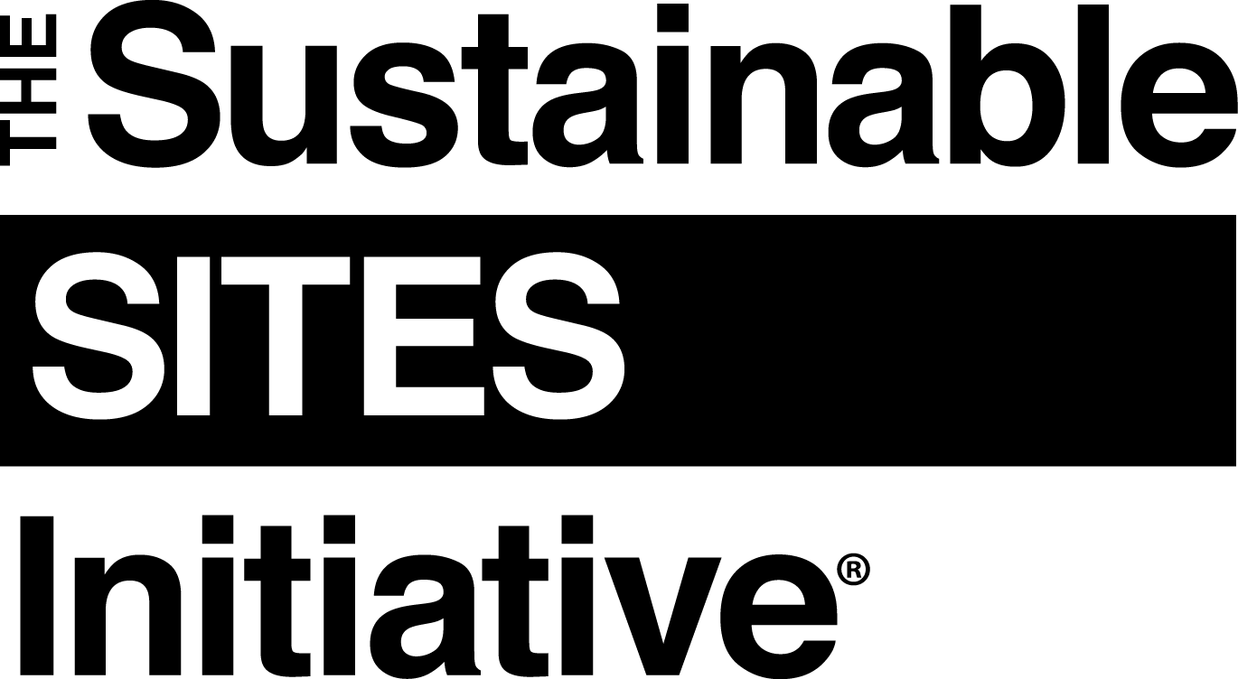

[DATE]

[COMPANY NAME]
[COMPANY ADDRESS]

Dear [COMPANY NAME],

Your organization is receiving this letter as a [provider, manufacturer or supplier] of materials for [PROJECT NAME] which is seeking certification via the Sustainable SITES Initiative® (SITES®). SITES is a comprehensive rating system and third-party certification that distinguishes high performance sites, measures their performance, and elevates the value of landscapes and other outdoor spaces in the built environment. It is administered by Green Business Certification Inc.TM (GBCI), and more information about the program (including a free download of the SITES v2 Rating System and Scorecard) is available at www.sustainablesites.org.
SITES Credit 5.8: Support transparency and safer chemistry aims to decrease harmful health and environmental impacts and encourage the use of safer alternatives by promoting the use of materials with available chemical inventories, lifecycle information, and hazard assessments.

To meet the intent of this credit and earn respective points in the SITES v2 Rating System, we are asking for your organization to develop and disclose chemical inventories and / or conduct chemical hazard assessments, per the guidance below, for the following products [select the appropriate products and delete the rest not requested from this provider, manufacturer or supplier]:

- Decking, railing, fencing, trellises, or lattices (wood and non-wood)
- Pipes, hoses, and irrigation components
- Conduit, wiring, and electrical equipment
- Lighting
- Membranes, liners, and geotextiles
- Fabrics and canvas
- Extruded, spray, or board foams
- Paints and coatings
- Adhesives, sealants, elastomers (e.g., flexible plastics), water proofing, weather stripping, expansion joint filling, and flashing
- Synthetic surfacing materials and associated products (e.g., crumb rubber, artificial turf)

Chemical inventories are defined as the listing of all chemicals associated with the manufacturing of a material and should include, to the extent known or reasonably ascertainable, all chemicals intentionally added by the manufacturer, any intermediate chemicals that may be wholly or partially consumed during the manufacturing process, and any process chemicals that may end up in manufacturing effluent or be otherwise released.
Chemical hazard assessment refers to the process of identifying product constituents; collecting, developing, and evaluating data on human health and environmental endpoints such as carcinogenicity, reproductive toxicity, neurotoxicity, aquatic toxicity, and persistence; and identifying potential hazards. This process allows for comparisons of alternatives to determine relative “greenness” and safety. The process also identifies areas for improvement. Chemical hazard assessments, focused on inherent risks of chemicals, do not take into account exposure scenarios as a more in-depth and lengthy risk assessment would.

[If pursuing Option 1 only, all text below this point may be deleted, up until the ‘Disclosure Documentation Guidance…’ section]

To demonstrate to GBCI that the requirements are met for this credit, please email the following documentation to [NAME AND COMPANY OF SITES PROJECT ADMINISTRATOR] at [EMAIL ADDRESS] by [DATE] along with a copy of this letter, indicating which documents are provided by checking the appropriate box.

To help us achieve 3 points for Option 2, please provide the following:
- Documentation demonstrating disclosure of material chemistry, including GHS-compliant (https://www.osha.gov/dsg/hazcom/ghsguideoct05.pdf), or otherwise complete Safety Data Sheets, and chemical safety reports for five percent or more of the products listed above. This includes:
  - Chemical inventories covering all chemicals, whether used intentionally or otherwise known to be present, in all life cycle stages of the product

In cases where the compilation of a complete chemical inventory is not feasible, the inventory requirements should cover chemicals and their life cycle stages thought to present the greatest hazards to workers, consumers, the general population, and environmental species.

  - A report of all known hazards and their concentrations regardless of whether the chemical’s presence in the product or process is intentional. This reporting includes the identification of any impurities, byproducts, and emissions from finished products or product curing steps.

To help us achieve 5 points for Option 3, please provide the following:

- Documentation for Option 2, AND

- Completed chemical hazard assessments from one of the following screening-level hazard assessment tools for five percent or more of the products using:

  - BizNGO’s Chemical Alternatives Assessment Protocol
  - GreenScreen for Safer Chemicals
  - U.S. EPA’s DfE Alternatives Assessment Criteria for Hazard Evaluation
  - U.S. EPA’s Sustainable Futures tool suite (to be used only when measured data is not available)
  - An equivalent robust hazard assessment strategy using recognized and reliable data sources.

Disclosure Documentation Guidance
All disclosures must adhere to the following standards:
- Each substance should be identified by the Chemical Abstract Service (CAS) name, number, and weight percentage, and include the identification or known impurities and byproducts.

- Criteria should be consistent with federal regulations, including the U.S. Occupational Safety and Health Administration (OSHA) Occupational and Health Hazard Communication Standard (29 CFR 1910); the U.S. Consumer Production Safety Commission Consumer Product Safety Act and Federal Hazardous Substances Act; and the U.S. Federal Trade Commission laws and guidelines prohibiting deceptive acts or practices, including deceptive representations in advertising, labeling, product inserts, catalogs, and sales presentations (or local equivalent for projects outside of the United States).

- For products required by the U.S. OSHA to have a safety data sheet (SDS), make a comprehensive SDS, in addition to all product ingredient and warning labels as required by the Consumer Product Safety Commission. SDSs should be provided for chemical components of formulated mixtures (particularly multi-component product systems) that undergo chemical reactions in situ. Also provide SDSs for final products resulting from such chemical reaction.

- For substances for which the manufacturer or supplier has developed an SDS consistent with the United Nations Globally Harmonized System of Classification and Labeling of Chemicals (GHS), only GHS-compliant SDSs will satisfy this requirement. For substances for which no GHS-compliant SDS is available, a report prepared within the previous five years in accordance with the NSF/GCI/ANSI 355 Greener Chemicals Products and Processes Information Standard shall be deemed to satisfy this requirement.
Please note: these requirements do not apply to products or materials that are salvaged, reused or refurbished.

If you have any questions regarding the requested information above, please email [NAME OF SITES PROJECT ADMINISTRATOR] from [COMPANY NAME] at [EMAIL ADDRESS] by [DATE]. Otherwise, please email the requested documentation by [DATE] along with a copy of this letter, indicating which documents are provided by checking the appropriate box.

Thank you for your participation in SITES and for your part in making sustainable places.

Sincerely,

[NAME of CONTACT for PROJECT]
[FIRM/COMPANY NAME OF PROJECT CONTACT]
[CONTACT INFO FOR PROJECT: ADDRESS, EMAIL, PHONE#]

