
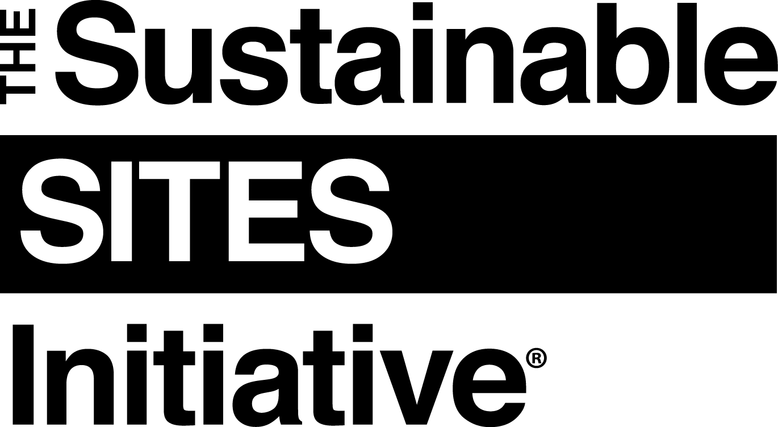

[DATE]

[COMPANY NAME]
[COMPANY ADDRESS]

Dear [COMPANY NAME],

Your organization is receiving this letter as a [provider, manufacturer or supplier] of new products for [PROJECT NAME] which is seeking certification via the Sustainable SITES Initiative® (SITES®). SITES is a comprehensive rating system and third-party certification that distinguishes high performance sites, measures their performance, and elevates the value of landscapes. It is administered by Green Business Certification Inc.TM (GBCI) and more information about the program (including a free download of the SITES v2 Rating System and Scorecard) is available at www.sustainablesites.org.

SITES Credit 5.9: Support sustainability in materials manufacturing aims to support sustainability in materials manufacturing by specifying and using materials from manufacturers whose practices increase energy efficiency, reduce resource consumption and waste, and minimize negative effects on human health and the environment.

To meet the intent of this credit and earn respective points in the SITES v2 Rating System, we are asking for your organization to perform, track and disclose sustainable practices for all new products used for this project, in at least one of the following ways, by:

- Reporting annual environmental performance via the Global Reporting Initiative (GRI) or equivalent; OR
- Conducting a peer-reviewed full life-cycle assessment (LCA) or an environmental product declaration (EPD) for the product; OR
- Publicly announcing goals to reduce, by at least twenty-five (25) percent (per unit product or equivalent basis) over a five (5) year period, the company’s performance metrics in the following categories:

- Use of energy, water, and toxics,
- Releases of key pollutants to air and water,
- Disposal of hazardous and non-hazardous wastes.

[If pursuing Option 1 only, all text below this point may be deleted, up until the ‘Emissions…’ checkbox. Replace the text that says, ‘To help us achieve 5 points for Option 3, please provide the documentation to demonstrate three or more of the following:’ with, ‘We also encourage organizations to conduct reporting and publish the following documentation:’]

To demonstrate to GBCI that the requirements are met for this credit, please email the following documentation to [NAME AND COMPANY OF SITES PROJECT ADMINISTRATOR] at [EMAIL ADDRESS] by [DATE] along with a copy of this letter, indicating which documents are provided by checking the appropriate box.

To help us achieve 3 points for Option 2, please provide one of the following:
- A report of annual environmental performance via the Global Reporting Initiative (GRI) or equivalent; OR
- A peer-reviewed full life-cycle assessment (LCA) or an environmental product declaration (EPD) for the product; OR
- Copies of public announcement regarding (or website link to) future environmental impact goals to reduce by at least twenty-five (25) percent (per unit product or equivalent basis) over a five (5) year period, the company’s performance metrics in the following categories:
      - Use of energy, water, and toxics,
      - Releases of key pollutants to air and water,
      - Disposal of hazardous and non-hazardous wastes.
To help us achieve 5 points for Option 3, please provide the documentation to demonstrate three or more of the following are conducted:

- Emissions: Reports demonstrating reductions of at least fifty (50) percent overall or per unit of product in at least two of the three (2 of the 3) categories below:

    - Emission of hazardous air pollutants (per U.S. Clean Air Act or local equivalent for projects outside of the U.S.)
    - Emissions of toxic water pollutants (per U.S. Clean Water Act or local equivalent for projects outside of the U.S.)
    - Generation of hazardous and non-hazardous waste (per U.S. Resource Conservation and Recovery Act or local equivalent for projects outside of the U.S.)

  - Greenhouse gas emissions: Emissions reports demonstrating that the three (3) lowest years for carbon emissions in the previous ten (10) years are at least twenty-five (25) percent better than the corresponding ten (10) year average (per unit of product) OR receipts for purchased carbon offsets from a legally binding trading system that provides independent third-party verification for twenty-five (25) percent of carbon emissions;

  - Reduced energy consumption: Documentation demonstrating consumption per unit of product of twenty-five (25) percent less energy than the industry average in the manufacturing process (consult the National Institute of Standards and Technology Building for Environmental and Economic Sustainability, the National Renewable Energy Laboratory U.S. Life-Cycle Inventory Database, or the Commercial Buildings Energy Consumption Survey for industry-specific data);

  - Use of renewable energy sources: Letter from the plant provider describing renewable energy sources to meet ten (10) percent of manufacturing electricity demands OR at least a four (4) year contract for the purchase of twenty (20) percent of electricity from renewable energy sources for the facility at which the product is made;

  - Reduction in potable water use: Calculations showing potable or other natural surface or subsurface water resources comprise less than twenty-five (25) percent and non-potable sources comprise at least seventy-five (75) percent of the total water volume consumed in manufacturing the specified product line (the calculations should include a brief description of the non-potable water sources).
Please note: these requirements do not apply to rocks, plants, soils, or products that are salvaged, reused or refurbished.

If you have any questions regarding the requested information above, please email [NAME OF SITES PROJECT ADMINISTRATOR] from [COMPANY NAME] at [EMAIL ADDRESS] by [DATE]. Otherwise, please email the requested documentation by [DATE] along with a copy of this letter, indicating which documents are provided by checking the appropriate box.

Thank you for your participation in SITES and for your part in making sustainable places.

Sincerely,

[NAME of CONTACT for PROJECT]
[FIRM/COMPANY NAME OF PROJECT CONTACT]
[CONTACT INFO FOR PROJECT: ADDRESS, EMAIL, PHONE#]

