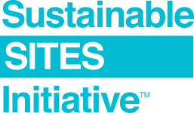
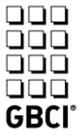

The SITES® v2 Materials Selection category contains four credits that, at a minimum, require the project team to submit a letter to providers, suppliers and / or manufacturers of applicable materials to advocate for sustainable practices and request disclosure of sustainable practices as outlined in the SITES v2 Rating System. Additional points are awarded to project teams that provide specific documentation to support sustainable materials practices.

GBCI has provided sample letters for each credit that the project team may choose to customize and submit to the responsible party for the following credits:

- C5.7: Support responsible extraction of raw materials
- C5.8: Support transparency and safer chemistry
- C5.9: Support sustainability in materials manufacturing
- C5.10: Support sustainability in plant production

Once sent (via email or snail mail), the letters may be used as documentation to demonstrate compliance with Option 1 of each credit above. They can also be used to collect documentation from providers, suppliers and / or manufacturers of materials for compliance with Options 2 and 3.

Instructions: Please customize the sample letters for your project to meet the requirements for the applicable credit. Your project team should update the text in [parenthesis], deleting options not pursued by the project, and removing instructions in red. Email or mail a PDF of the letter to the responsible party asking them to return a copy of each requested document that discloses sustainable extraction practices. It may also be helpful to send a PDF copy of the credit requirements and / or a copy of the SITES v2 Rating System with the page number for their reference. These documents are available as a free download at www.sustainablesites.org.

For technical assistance, please email sites@gbci.org.

